HOUSE RENT APP USING MERN

NAAN MUDHALVAN PROJECT:

House Rent App Using MERN

PROJECT MEMBERS:

1.SOUNDARYA.D – Soundarya.d07@gmail.com

2.SHAFRIN FARZANA.U - shafrinfarzana0@gmail.com

3.NAFEESA SANAD.S - nafeesasanad@gmail.com

4.SRIDHARAN.D - sridharan7869@gmail.com

INTRODUCTION:

The rental housing market is a vital component of urban economies, where finding the right rental property can often be a complex and time-consuming task. With the increasing demand for streamlined solutions, a modern approach to property rental management is essential. The House Rent Application, built using the MERN stack (MongoDB, Express.js, React.js, Node.js), aims to simplify the rental process for both tenants and landlords by providing a user-friendly, efficient, and feature-rich platform.

This application serves as a bridge between tenants looking for rental properties and landlords seeking reliable tenants for their properties. It provides advanced search filters, real-time communication, and property management tools, making the entire renting process seamless. The app leverages the power of the MERN stack to offer a responsive front-end user interface (React.js), robust backend infrastructure (Node.js and Express.js), and a scalable database (MongoDB) for storing listings, user information, and transactions.

With this application, users can easily browse listings, communicate with landlords, and manage their rental history, while landlords can efficiently list their properties, manage tenant communications, and ensure a smooth rental experience.

ABSTRACT:

The House Rent Application is a comprehensive web-based solution developed using the MERN stack (MongoDB, Express.js, React.js, Node.js) to bridge the gap between tenants and landlords in the rental housing market. The platform allows tenants to search for available rental properties, communicate with landlords, and manage their rental details, while landlords can list properties, manage inquiries, and maintain property records. The app features advanced search filters for property types, locations, prices, and amenities, enabling tenants to find homes that best fit their needs.

On the backend, MongoDB serves as a scalable, NoSQL database for storing property listings, user profiles, and transactions, while Node.js and Express.js handle the server-side logic and API requests. React.js powers the dynamic, responsive frontend, providing users with an intuitive and interactive experience. The app includes essential features such as user authentication, real-time messaging between tenants and landlords, and property booking functionalities, ensuring seamless communication and a smoother rental process.

The House Rent Application aims to modernize and simplify the renting process by offering a centralized platform for users to find, manage, and interact with rental properties, providing a solution that benefits both landlords and tenants in an increasingly digital world.

SCENARIO BASED CASE STUDY:

Scenario: Renting an Apartment

**User Registration:** Alice, who is looking for a new apartment, downloads your house rent app and registers as a Renter. She provides her email and creates a password.

**Browsing Properties:** Upon logging in, Alice is greeted with a dashboard showcasing available rental properties. She can see listings with detailed descriptions, photos, and rental information.

She applies filters to narrow down her search, specifying her desired location, rent range, and the number of bedrooms.

**Property Inquiry:** Alice finds an apartment she likes and clicks on it to get more information. She sees the property details and owner's contact information.

Interested in renting, Alice fills out a small form with her details and sends it to the owner.

**Booking Confirmation:** The owner receives Alice's inquiry and reviews her details. Satisfied, the owner approves Alice's booking request.

Alice receives a notification that her booking is confirmed, and the status in her dashboard changes to "pending owner confirmation."

**Admin Approval (Background Process):** In the background, the admin reviews new owner registrations and approves legitimate users who want to add properties to the app.

**Owner Management:** Bob, a property owner, signs up for an Owner account on the app and submits a request for approval.

The admin verifies Bob's credentials and approves his Owner account.

**Property Management:** With his Owner account approved, Bob can now add, edit, or delete properties in his account.

He updates the status and availability of his properties based on their occupancy.

**Platform Governance:** Meanwhile, the admin ensures that all users adhere to the platform's policies, terms of service, and privacy regulations.

The admin monitors activities to maintain a safe and trustworthy environment for all users.

**Transaction and Lease Agreement:** Once Alice's booking is confirmed, she and the owner negotiate the terms of the lease agreement through the app's messaging system.

They finalize the rental contract and payment details within the app, ensuring transparency and security.

**Move-in Process:** Alice successfully moves into her new apartment, marking the completion of the rental process facilitated by the house rent app.

This scenario highlights the main functionalities of your MERN-based house rent app, including user registration, property browsing, inquiry and booking process, admin approval, owner management, platform governance, and the overall rental transaction.

TECHNICAL ARCHITECTURE:

The technical architecture of our House rent app follows a client-server model, where the frontend serves as the client and the backend acts as the server. The frontend encompasses not only the user interface and presentation but also incorporates the axios library to connect with backend easily by using RESTful Apis.

The frontend utilizes the bootstrap and material UI library to establish real-time and better UI experience for any user whether it is admin, doctor and ordinary user working on it.

On the backend side, we employ Express.js frameworks to handle the server-side logic and communication.

For data storage and retrieval, our backend relies on MongoDB. MongoDB allows for efficient and scalable storage of user data, including user profiles, for booking room, and adding room, etc. It ensures reliable and quick access to the necessary information.

Together, the frontend and backend components, along with moment, Express.js, and MongoDB, form a comprehensive technical architecture for our House rent app. This architecture enables real-time communication, efficient data exchange, and seamless integration, ensuring a smooth and

immersive booking an appointment and many more experience for all users.

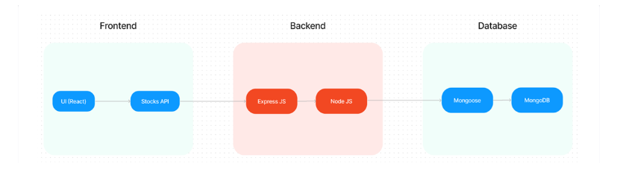

ER DIAGRAM:

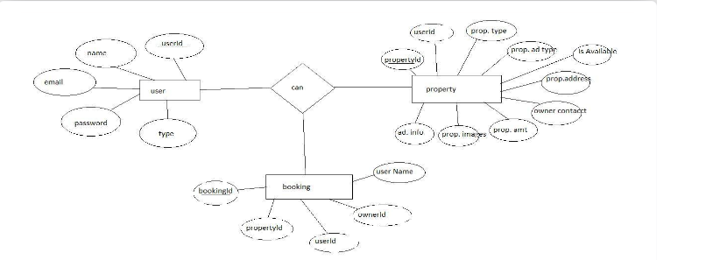

Here there is 3 collections namely users, property, and booking which have their own fields in

Users:

1. _id: (MongoDB creates by unique default)
2. name
3. email
4. password
5. type

Property:

1. userID: (can be act as foreign key )
2. _id: (MongoDB creates by unique default)
3. prop.Type
4. prop.AdType
5. isAvailable
6. prop.Address
7. owner contact
8. prop.Amt
9. prop.images

10.add.Info

Booking

1. _id:  (MongoDB creates by unique default)
2. propertId
3. userId
4. ownerId
5. username

PRE-REQUISITES:

Here are the key prerequisites for developing a full-stack application using Node.js, Express.js, MongoDB, React.js:

?**Node.js and npm:**

Node.js is a powerful JavaScript runtime environment that allows you to run JavaScript code on the server-side. It provides a scalable and efficient platform for building network applications.

Install Node.js and npm on your development machine, as they are required to run JavaScript on the server-side.

**npm init**

?**Express.js:**

Express.js is a fast and minimalist web application framework for Node.js. It simplifies the process of creating robust APIs and web applications, offering features like routing, middleware support, and modular architecture.

Install Express.js, a web application framework for Node.js, which handles server-side routing, middleware, and API development.

Installation: Open your command prompt or terminal and run the following command:

**npm install express**

?**MongoDB:**

MongoDB is a flexible and scalable NoSQL database that stores data in a JSON-like format. It provides high performance, horizontal scalability, and seamless integration with Node.js, making it ideal for handling large amounts of structured and unstructured data.

Set up a MongoDB database to store your application's data.

 ?**Moment.js:**

Momentjs is a JavaScript package that makes it simple to parse, validate, manipulate, and display date/time in JavaScript. Moment. js allows you to display dates in a

human-readable format based on your location. Install React.js, a JavaScript library for building user interfaces.

?**React.js:**

React.js is a popular JavaScript library for building user interfaces. It enables developers to create interactive and reusable UI components, making it easier to build dynamic and responsive web applications.

Install React.js, a JavaScript library for building user interfaces.

?**Antd:**

Ant Design is a React. js UI library that contains easy-to-use components that are useful for building interactive user interfaces. It is very easy to use as well as integrate. It is one of the smart options to design web applications using react.

?**HTML, CSS, and JavaScript**: Basic knowledge of HTML for creating the structure of your app, CSS for styling, and JavaScript for client-side interactivity is essential.

?**Database Connectivity**: Use a MongoDB driver or an Object-Document Mapping (ODM) library like Mongoose to connect your Node.js server with the MongoDB database and perform CRUD (Create, Read, Update, Delete) operations

?**Front-end Framework**: Utilize Reactjs to build the user-facing part of the application, including entering booking room, status of the booking, and user interfaces for the admin dashboard.

For making better UI we have also used some libraries like material UI and boostrap.

Install Dependencies:

• Navigate into the cloned repository directory:

cd house-rent

• Install the required dependencies by running the following commands:

cd frontend

npm install

cd ../backend

npm install

Start the Development Server:

• To start the development server, execute the following command:

npm start

• The house rent app will be accessible at [http://localhost:3000](http://localhost:3000/)

You have successfully installed and set up the online complaint registration and management app on your local machine. You can now proceed with further customization, development, and testing as needed.

PROJECT STRUCTURE:

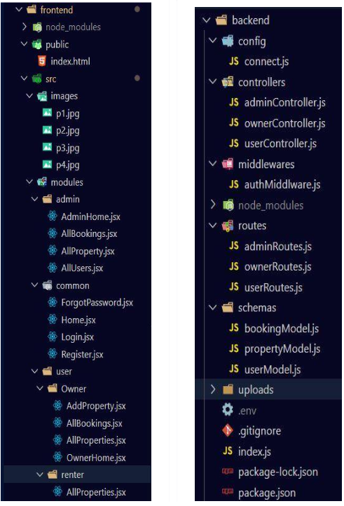

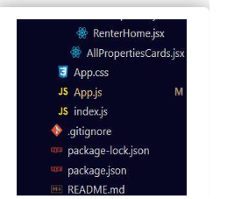

The first image is of frontend part which is showing all the files and folders that have been used in UI development

The second image is of Backend part which is showing all the files and folders that have been used in backend development.

APPLICATION FLOW:

**Roles and Responsibilities:**

The project has 2 type of user – Renter and Owner and other will be Admin which takes care to all the user. The roles and responsibilities of these two types of users can be inferred from the API endpoints defined in the code. Here is a summary:

Renter/Tenent:

1. Create an account and log in to the system using their email and password.
2. They will be shown automatically all the properties in their dashboard.
3. After clicking on the Get Info, all the information of the property and owner will come and small form will generate in which the renter needs to send his\her details.
4. After that they can see their booking in booking section where the status of booking will be showing “pending”. It will be change by owner of the property.

Admin:

5.He/she can approve the user as “owner” for the legit user to add properties in his app

6.He monitors the applicant of all doctors and approve them and then doctors are registered in the app.

7.Implement and enforce platform policies, terms of service, and privacy regulations.

Owner:

8.Gets the approval from the admin for his Owner account.

9.After approval, he/she can do all CRUD operation of the property in his/her account

10.He/she can change the status and availability of the property.

PROJECT FLOW:

* **Folder setup:**

1. Create frontend and
2. Backend folders

2. Open the backend folder to install necessary tools

For backend, we use:

* cors
* bcryptjs
* express
* dotenv
* mongoose
* Moment
* Multer
* Nodemon
* Jsonwebtoken

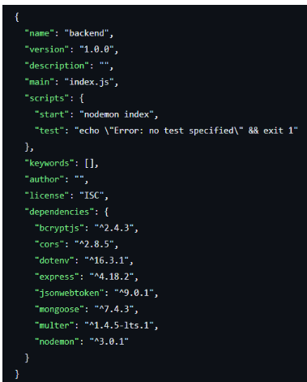

BACKEND DEVELOPMENT:

**Setup express server**

1. Create index.js file in the server (backend folder).
2. define port number, mongodb connection string and JWT key in env file to access it.
3. Configure the server by adding cors, body-parser.

**Add authentication:** for this,

1. You need to make middleware folder and in that make authMiddleware.js file for the authentication of the projects and can use in.

DATABASE DEVELOPMENT:

* **Configure MongoDB**

1. Import mongoose.
2. Add database connection from config.js file present in config folder
3. Create a model folder to store all the DB schemas like renter, owner and booking, and properties schemas.

FRONTEND DEVELOPMENT:

* **Installation of required tools:**
* For frontend, we use:

1. React
2. Bootstrap
3. Material UI
4. Axios
5. Moment
6. Antd
7. mdb-react-ui-kit
8. react-bootstrap

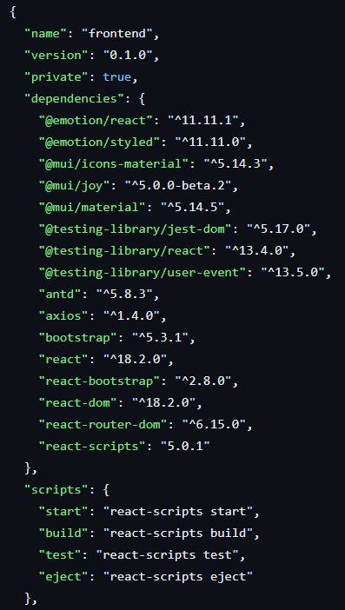

PROJECT IMPLEMENTATION AND EXECUTION:

On completing the development part, we then run the application one last time to verify all the functionalities and look for any bugs in it. The user interface of the application looks a bit like the one’s provided below.

* **Landing page:**

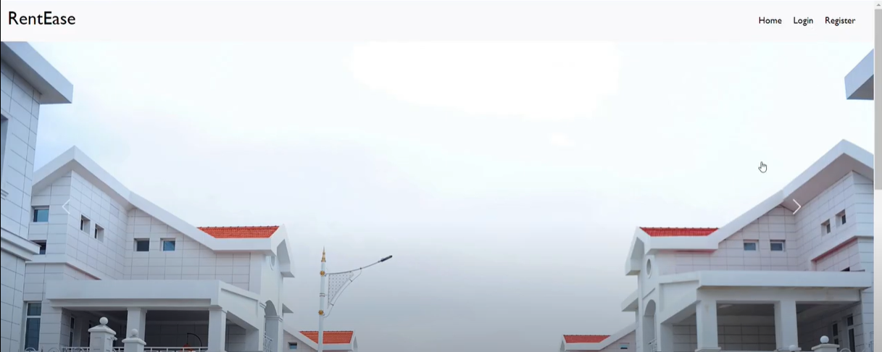

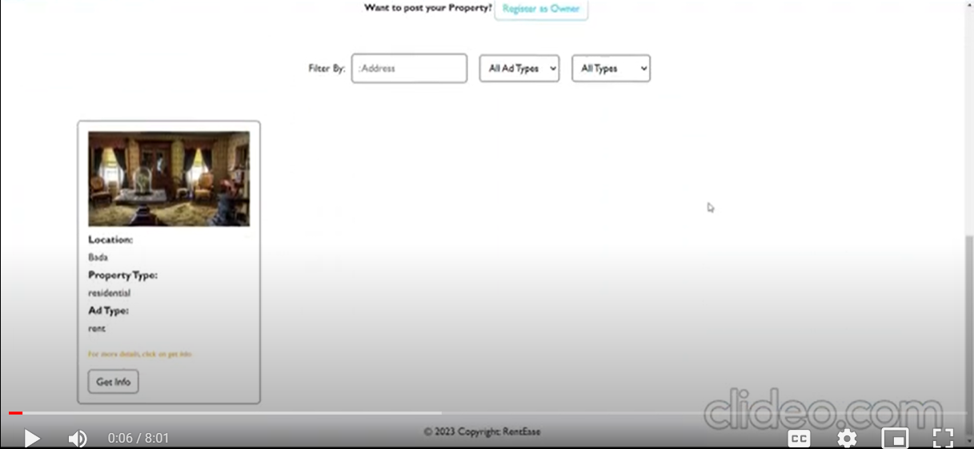

* **Login and register page: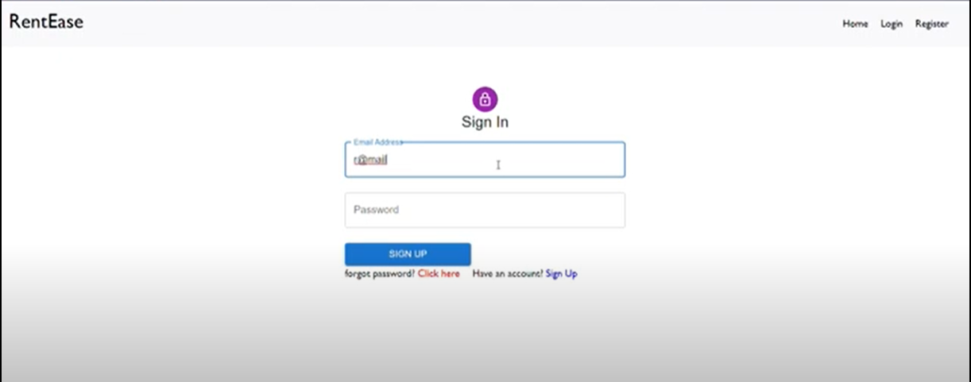 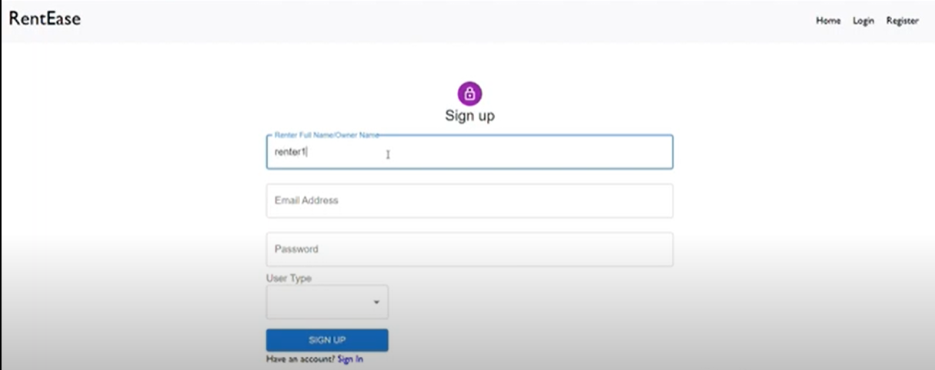 . Admin Panel:**

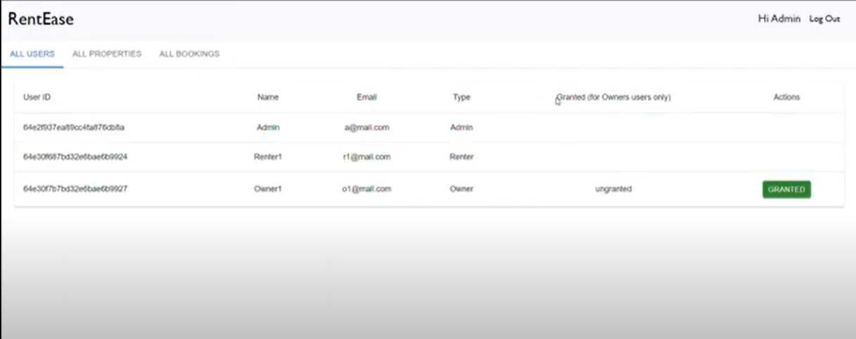

* **Owner Panel:**

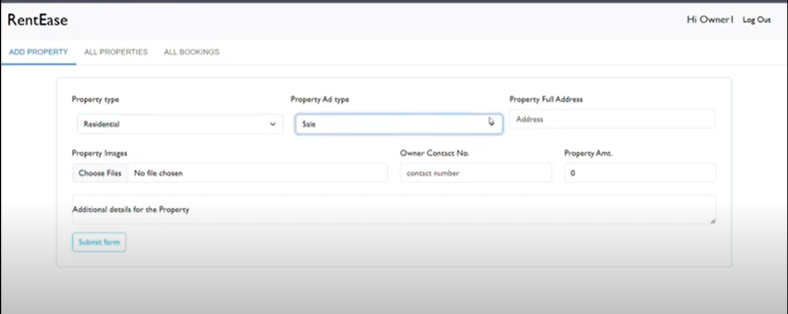

* **Tenant panel:**

